CSE 421 ASSIGNMENT 1

Can Sarp Arıdoğan
Ahmet Renda Şendağ
Q1)
Before getting in to the actual question, we did some orientation on the board with a basic blinky example. Because we are using a mac device, after compiling the code on Mbed studio, we couldn’t flash it to the board. To send the program from our computer to the board, we used the STM32 Cube Programmer CLI software. After compiling the code in Mbed studio, we ran the code from the mac terminal. To read the temperature data, we need to use the TSENSOR library.
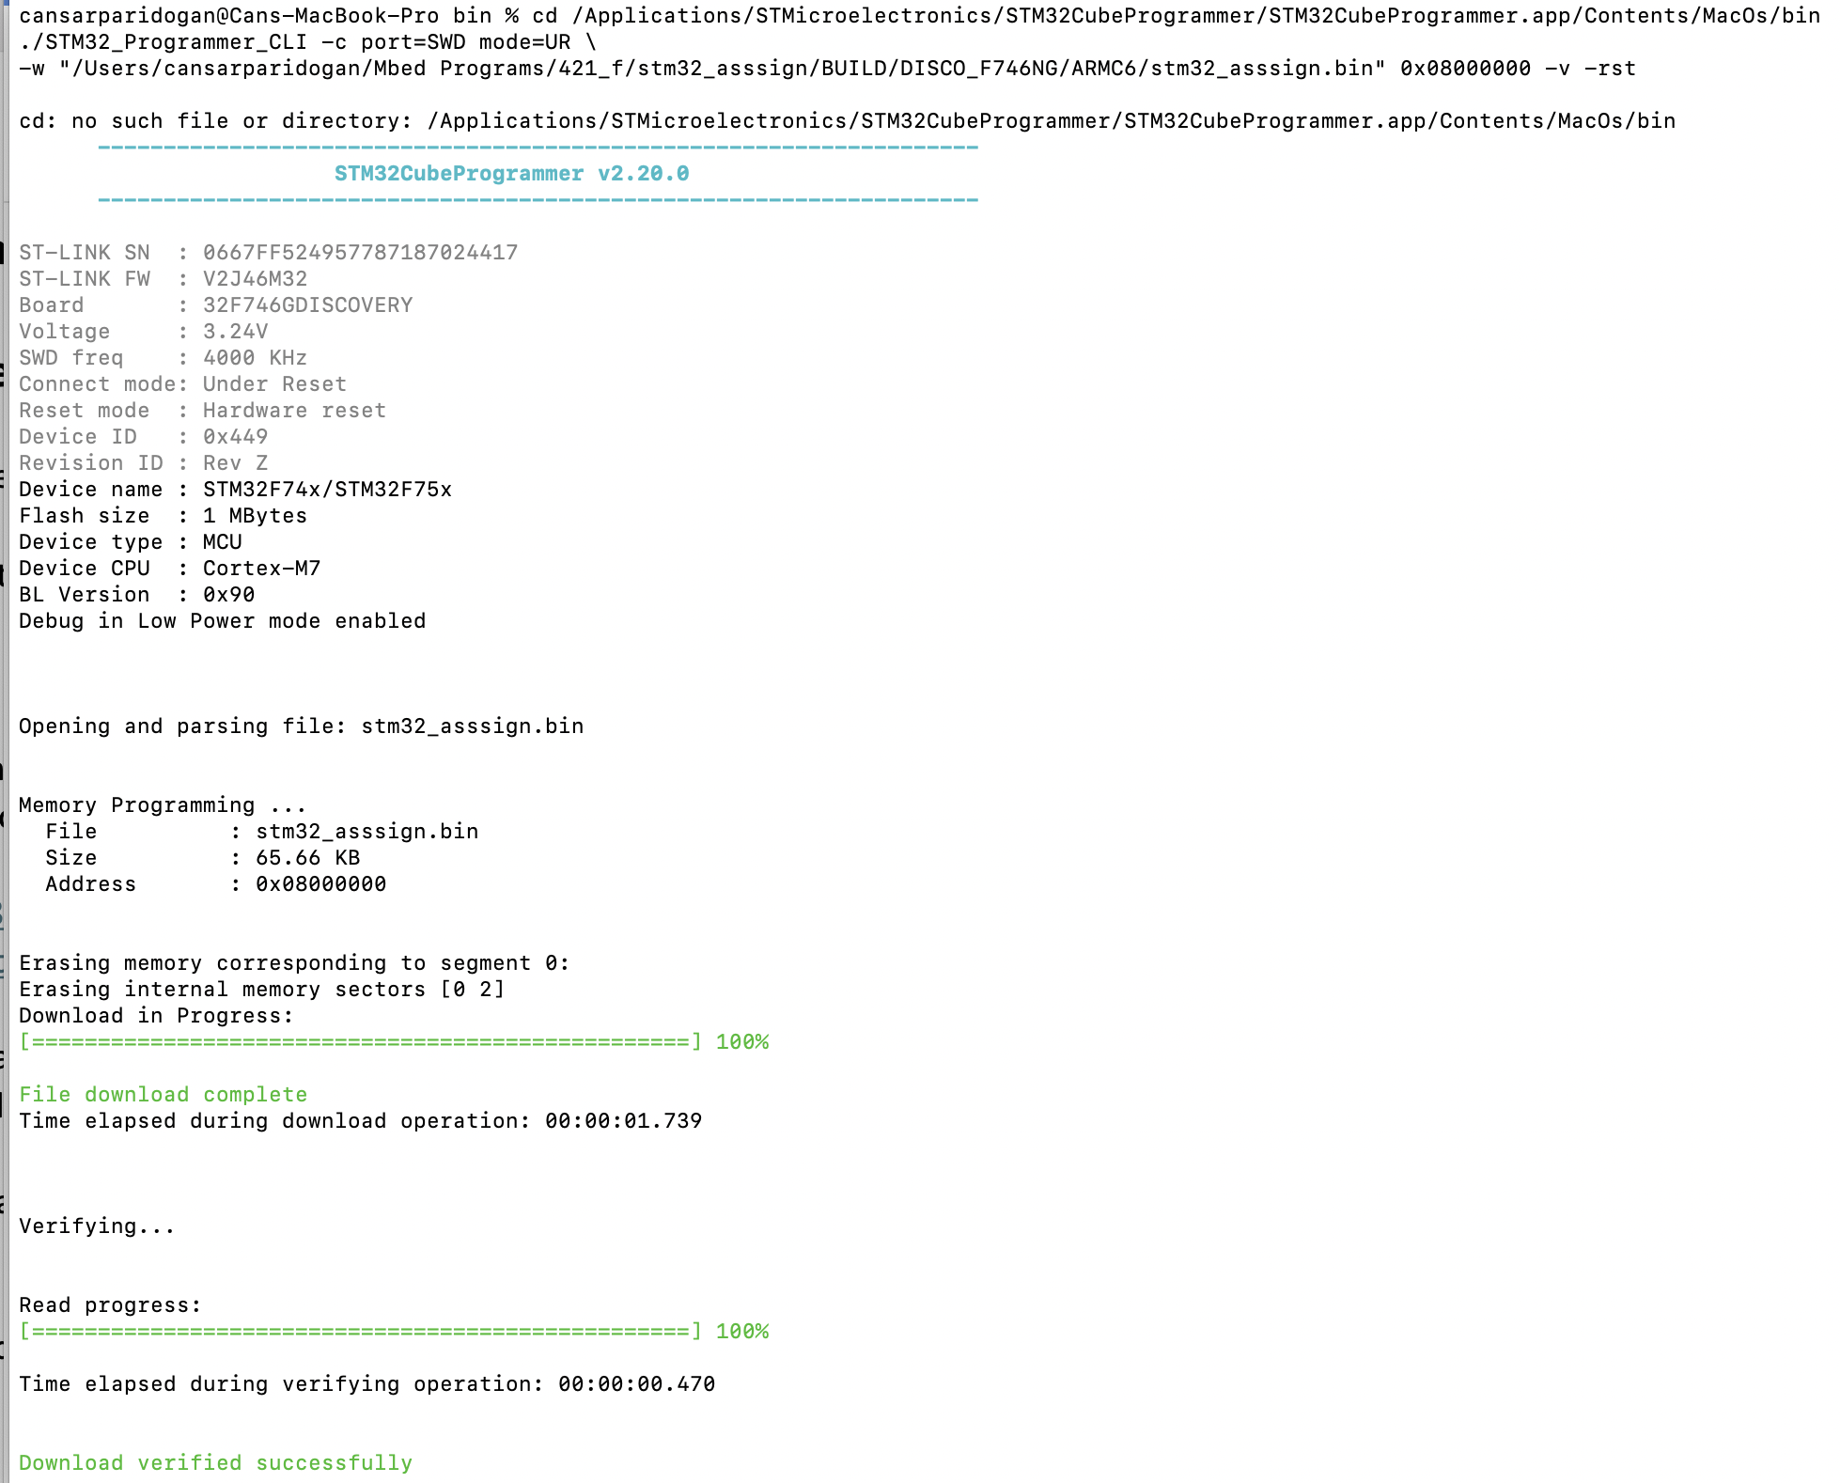
cd /Applications/STMicroelectronics/STM32CubeProgrammer/STM32CubeProgrammer.app/Contents/MacOs/bin
./STM32_Programmer_CLI -c port=SWD mode=UR \
-w "/Users/cansarparidogan/Mbed Programs/421_f/stm32_asssign/BUILD/DISCO_F746NG/ARMC6/stm32_asssign.bin" 0x08000000 -v -rst
With this terminal command, we run the program on the board.

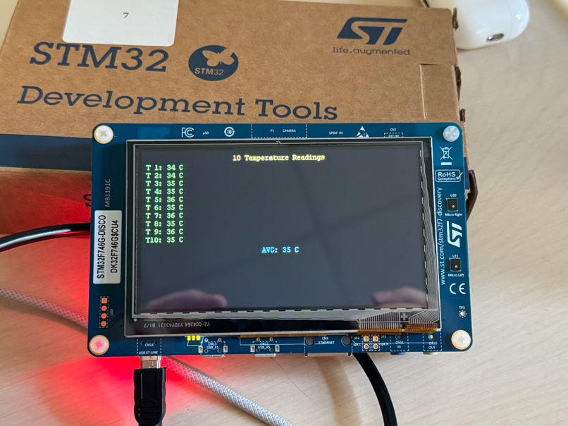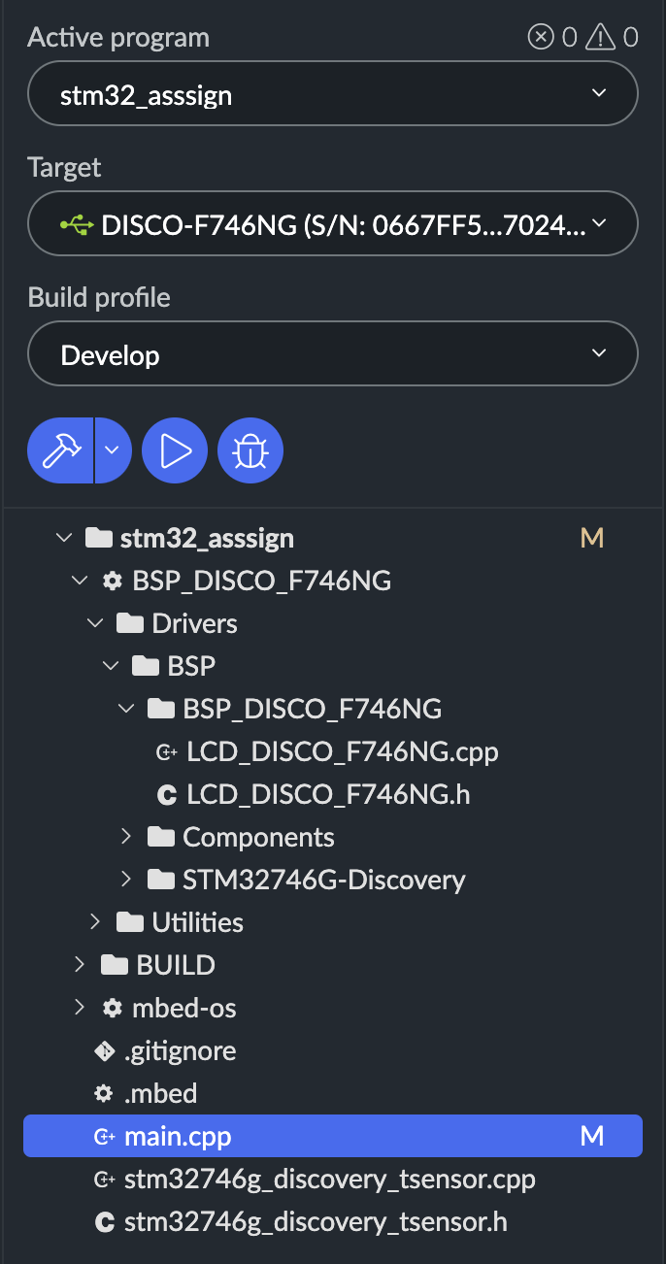

Q2)
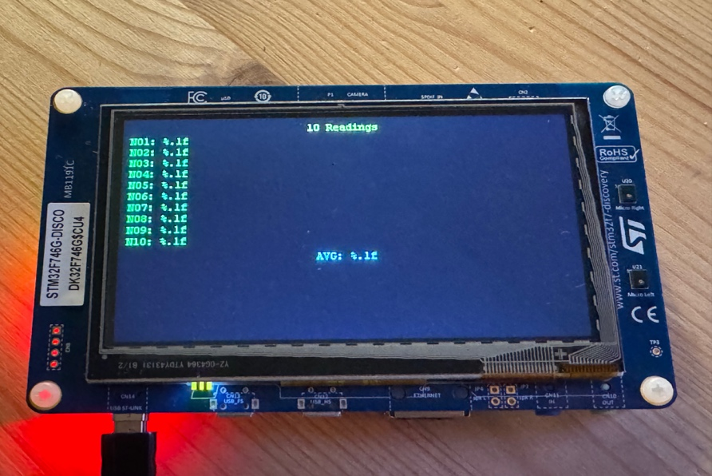

This program reads analog voltage values from an LDR or potentiometer using the STM32s ADC, averages ten samples, and displays the results on the LCD screen. The readings represent either approximate light intensity or relative brightness depending on configuration. It also blinks an onboard LED as a status indicator while sampling.

